CSP

Echo command



Date



ls command



Ls -1 command

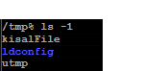

Cd temp folder

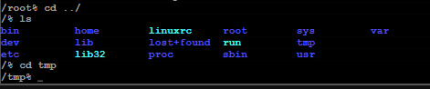

CREATE FOLDER



LS



LS -1

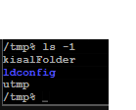

kisalFolder’s file permissions

